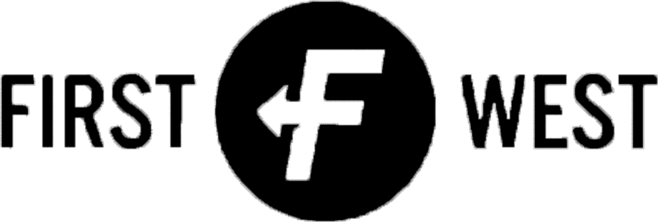 | | Multiplication Grid
First West's strategy is to #seetoit that no one misses the grace of God with Christ-centered worship, community and service. The key way we can do that in Northeast Louisiana (NELA) is through a multiplication of our reach in new areas.

We have four distinct kinds of opportunities:

- Launching a First West regional campus
- Repurposing an existing church belonging to a struggling congregation
- Planting a new church
- Initiating a strategic partnership

Since we recognize an abundance of opportunities in NELA and have limited resources to invest, we commit to meet a set of conditions before proceeding with any multiplication opportunity.

Strategic Criteria – Regional Campus

- Capital Investment – Our maximum initial outlay for a regional campus will be $250,000. For new purpose-built construction on a major thoroughfare, the maximum capital expense will $2.5 million. The capital expense outlay will justify the future ministry potential and must address the question of opportunity cost.
- Frequency – We will launch a regional campus every 3 to 5 years.
- Location – The location will be more than 15 minutes drive, but less than 45 minutes drive, from a current campus.
- Existing Penetration – 50 or more First West families must reside in the vicinity.
- Community Demographics – The demographic profile of the area will be comparable to our existing demographic profile.
- Saturation Point – We will consider the saturation point for regional campuses in NELA.
- Physical and Geographic Barriers – We will examine real and perceived barriers that might limit regional draw (highways or rivers, perceived barriers like boundary lines dividing distinct communities or neighborhoods, etc.).
- Area Churches – We will not disrupt or destroy surrounding congregations that can’t compete with the level of ministry our resources and abilities provide.
- Community Need – We will place regional campuses in areas underserved by other churches. If there are other churches nearby already providing our method and style of ministry, we will outline the benefits we bring to the community.

Strategic Criteria – Repurposing a Church

- Regional Campus Criteria – A church repurposing will meet the conditions detailed above for First West regional campuses.
- Capital Investment – Our maximum outlay for a church repurposing will be $250,000. The capital expense outlay will not be cost prohibitive.
- Location – The location must be visible and strategic. We will consider repurposing only when a church is located on a major thoroughfare with high daily traffic volume.
- Existing Leadership – Present church leaders will consent to an infusion of new vision, culture and DNA. This include a full restart and rebranding after a minimum two-month waiting period.
- Branding – Churches repurposed will take on First West campus branding.
- Sustainability – The church and community must satisfy the requirement for a long-term average worship attendance of 150 or more, and preferably 200 or more.

Strategic Criteria – Church Plant

- Capital Investment – Our maximum outlay for a strategic church plant will be $75,000.
- Frequency – We will plant a new church every 3-5 years in NELA, NOLA and the world.
- Location – New churches will be started in areas where First West branding, reach and influence are not prevalent.
- Branding – Church plants will be branded to match the community context.
- Existing Penetration – Very few First West families will reside in areas selected for church planting. Fewer than 50 First West families will reside in the vicinity.
- Community Demographics –The demographic profile of the area will be unlike our existing demographic profile. Church plants have the capacity to reach parts of our community that a First West regional campus cannot.
- Saturation Point – We will consider the saturation point for churches in communities identified for church planting.
- Community Need – We will plant churches in areas underserved by other churches.
- Sustainability – The church and community must satisfy the requirement for a long-term average worship attendance of 100 or more.

Strategic Criteria – Strategic Partnership

- Covenant Agreement – Any strategic partnership will require a covenant agreement between First West and the candidate church. The covenant will detail revitalization scope, costs and timeline, along with each church’s responsibilities.
- Capital Investment – Our maximum outlay for a strategic partnership will be $35,000.
- Frequency – We will revitalize a church every 4-6 years.
- Location – Churches will be revitalized in areas where First West branding, reach and influence are not prevalent. Underserved urban and rural areas are likely candidates for a strategic partnership.
- Branding – Church revitalization may require a church to change its core identity, but will not require First West branding.
- Existing Penetration – Very few First West families will reside in areas selected for church planting. Fewer than 50 First West families will reside in the vicinity.
- Community Demographics – The demographic profile of the area may or may not be similar to our existing demographic profile.
- Community Need – We will plant churches in areas underserved by other churches.
- Sustainability – The church and community must satisfy the requirement for a long-term average worship attendance of 100 or more.

CHURCH STARTING
& REVITALIZATION
FIRST WEST CAMPUS
MULTIPLICATION
 | CORE MULTIPLICATION  STRATEGY | ENHANCED  OPPORTUNITY
 | REGIONAL  CAMPUS  $250,000 maximum investment  New campus every 3-5 years  Less than 45 minutes away  50 or more First West families  Comparable demographic profile  No disruption of area churches  Placed in underserved areas | REPURPOSING  A CHURCH  Meets regional campus conditions  $250,000 maximum investment  Location must be visible and strategic  Infusion of new vision  Full restart and rebranding  Minimum 2-month pause to restart  Long-term average attendance of 150+
 | CHURCH  PLANT  $75,000 maximum investment  New church plant every 3-5 years  Beyond our influence and reach  Branded for community context  50 or fewer First West families  Dissimilar demographic profile  Placed in underserved areas  Long-term average attendance of 100+ | STRATEGIC  PARTNERSHIP  Covenant agreement required  $35,000 maximum investment  Partnership initiated every 4-6 years  Beyond our influence and reach  No requirement to change core identity  50 or fewer First West families  Dissimilar demographic profile  Long-term average attendance of 100+

