WEST MONROE, LA

NEXTGEN PASTOR
POSITION PROFILE

OVERVIEW
First West is a missions-minded, family-focused and growing Southern Baptist Church with over 2,000 attending weekend services. With a well-established legacy of changed lives in northeast Louisiana (NELA), First West is poised for an exciting future full of hope for serving Christ and expanding His Kingdom in NELA, NOLA and the world.

Under the leadership of Lead Pastor Michael Wood, First West members, ministry teams and staff are committed to #seetoit that no one misses the grace of God. Life change happens through Christ-centered evangelism, worship, community and service.

With two campuses and plans for a third, First West is embracing what it means to be one church in several locations. Worship at the West Monroe campus includes both conventional and contemporary services, while worship at other locations offer a contemporary service only.

The church seeks a NextGen Pastor to provide leadership and management to Preschool, Children’s and Student Ministry Teams and the people to whom they minister, providing them with the best opportunity to become fully developing followers of Christ.

MISSION & VISION
Our vision is where we’re going.
- We will see people changed by the gospel and living out their Christ-centered purpose.

Our mission is what we’re doing.
- We are seeing to it that no one misses the grace of God.

STRATEGY & VALUES
Our strategy is how we’re getting it done.
- Evangelism – We will train people to share their 1 story and memorize 1 verse and ask them to commit to share with 1 person.
- Worship – We will multiply worship leaders and grow worship services across all campuses.

- Community – We will develop new leaders and start new LIFE Groups.
We will multiply leaders in our NextGen Ministry and make every campus inviting for preschoolers, children, students and families.
- Service – We will increase volunteers serving in local ministries and on short-term mission trips.

Our values are why we’re doing it.
- Sharing – We share Jesus with everyone.
- Growing – We grow together and live all out for Jesus.
- Multiplying – We multiply the church in NELA, NOLA and the world.

RESPONSIBILITIES
The NextGen Pastor works closely with members and staff to support the vision of First West and its campuses in developing and leading a Merge-type discipleship strategy for preschoolers, children, students and their parents/guardians to support an overall strategy of Family Ministry.

The search is for a person who has a passion for the church of Jesus Christ and its mission of disciple making. The NextGen Pastor will have direct responsibility and supervisory responsibility for:

- Total church Family Ministry and Merge Strategy development and implementation
- Formulation of a family discipleship strategy for preschoolers, children, students and parents/guardians
- Working with Family Ministry Teams to enlist, train and multiply staff and volunteer leaders
- Working with assigned Preschool, Children’s and Students Ministry Leaders to formulate and oversee the Family Ministry strategy and budget
- Serving as a member of the Senior Lead Team
- Leading as NextGen Champion across all First West campuses
- Providing resources for all campus Preschool, Children’s and Student Ministries
- Serving as team leader for the West Monroe Campus Family Ministry Team, consisting of Preschool, Children’s and Students’ Ministry Teams
  - Student Ministry Pastor—West Monroe Campus
  - Preschool Minister
  - Children’s Director
  - Children & Preschool Assistant
  - Children & Preschool Curriculum Coordinator
- Leading and managing First West’s Residency Program (Ministry Internships)
- Pastoral care staff responsibilities including hospital visits, meetings and other ministry opportunities
- Fostering a positive and cooperative attitude and team spirit
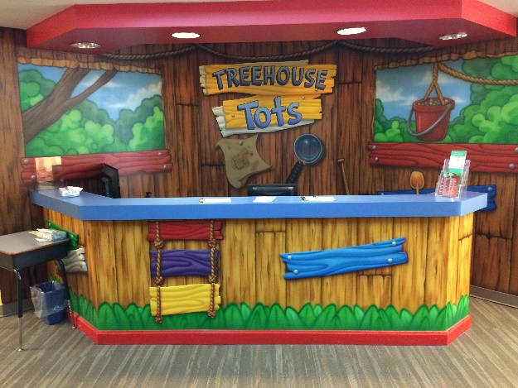
The NextGen Pastor works closely with First West’s Discipleship and Young Married Adults Ministry and has three additional focus points:

- Intentional Marriages
- Intentional Parents
- Intentional Families

QUALIFICATIONS
The foremost requirement for this role is that of a Christ-centered life. The successful candidate will have a deep and ever-growing relationship with God as evidenced by daily habits of spending time with Him and His Word, observable fruits of the spirit, active involvement in the leadership of a church, and a commitment to maintaining healthy accountability relationships with a small number of mature believers. A strong sense of calling will be evident.

In evaluating individuals for the position of NextGen Pastor, we will consider several key qualifications:

- Godly Character and a Christ-Centered Life
- A Clear Calling to Work with Preschoolers, Children, Students and Their Families
- Family Ministry Competency and Experience
- Chemistry with Other Ministry Team Members
- An Understanding of Relational Ministry
- Leadership Skills (including the ability to recruit and develop others)
- Management Ability (including budgeting and supervising)
- Creativity and Innovative Thinking about Ministry to the Next Generation
- A Strong Work Ethic
- A Commitment to Excellence

Contenders for this role will have 10+ years experience as an age division minister or Family Minister at a large church with multiple staff members and team-based ministry. They will be teachable and have a strong commitment to self and staff development.

Viable candidates must give evidence of the ability to lead and appropriately hold accountable individuals, groups and teams that produce measurable results against predetermined goals and objectives. A participative, collaborative, team-oriented culture is the desire at First West and this leader must be characterized by these same values.

This role will call for someone with substantive implementation, influencing and relational skills. Thus, this person must be a leader who can accomplish agreed upon results through people by deeply valuing people and relating well to those of all ages and levels of spiritual maturity. It is essential he have well-developed interpersonal relationship skills and social intelligence. Furthermore, this minister must be able to effectively share God’s Word and ably communicate via the written and spoken word.

While seminary degrees and ordination are preferred rather than specific requirements, a well-established theological construct, ecclesiology, and an in-depth knowledge of scripture is necessary for the wisdom and biblically-based, decision-making demands of this position. Leading candidates will possess a biblical theology that is consistent with that of the Lead Pastor.

Further, this is the role of a minister. A shepherd’s approach is a must; thus, this person will possess personal warmth that brings comfort, peace, wise counsel and harmony to relationships and the work environment.

PERSONALITY, GIFTS, ABILITIES AND STRENGTHS
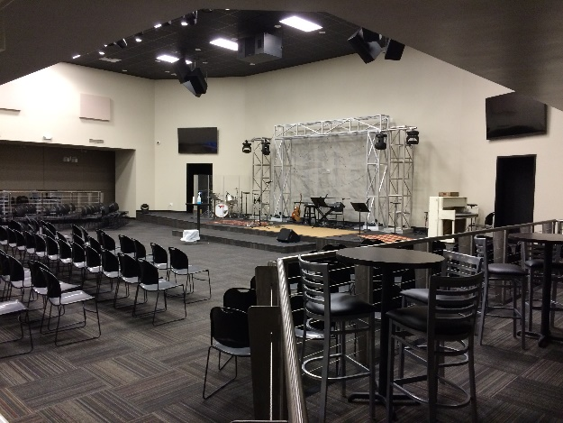
Personality: Using the DISC personality profile assessment tool, we will expect this person to evidence an appropriate blend of S, C and D personality characteristics.

Spiritual Gifts: Using the PLACE assessment tool, we will look for the support gift of Administration and equipping gifts such as Leadership, Wisdom, Discernment, Encouragement or Teaching.

Abilities: Using the PLACE assessment tool, we will look for Enterprising and Investigative abilities with Social and Conventional abilities being secondary.

Passions: Using the PLACE assessment tool, we will look for a passion mix of Leading, Influencing, Improving, Organizing and Developing.

Strengths: Using the Gallup StrengthsFinder assessment, we will look for a person with strengths in the following prioritized domains: Executing, Influencing and/or Relationship Building, Strategic. We will expect to see two to three Executing Strengths and at least one Influencing and/or Relationship Building strengths. A Strategic strength will be considered a plus.

